Temp document
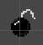
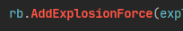
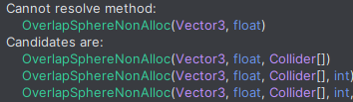
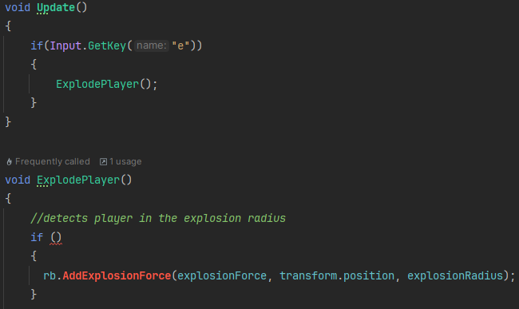
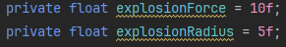
Creating explosion to help the player move. Needed a way to propel the player. Unity has an AddExplosionForce, which I can use to add a force to the player from the bomb. At the moment, I would call the function ExplodePlayer when the ‘e’ key was pressed. Temporary for testing. Want to detect player to see if a force should be applied. Stuck so looked it up. Used tutorial from (gamedevbeginner, 2025) but it was on how to apply the force to multiple colliders when I only wanted to apply it to the player, makes it simpler for player. Can use layer mask to choose what layers it applies to. Needed to use Collider[] array as a parameter.
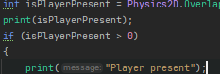
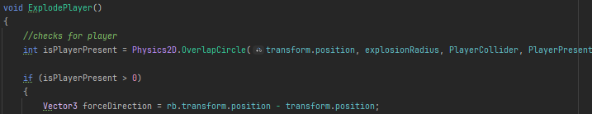
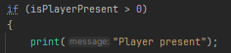
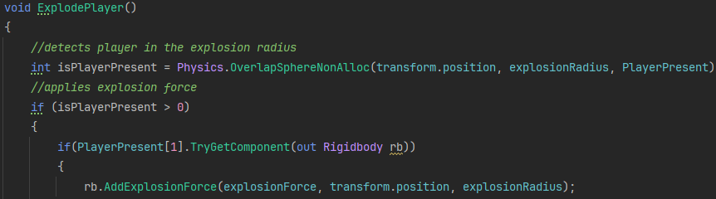
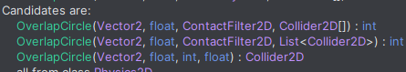
Couldn’t resolve. Try to fix, works with out Rigidbody rb in the if statement. Debugging, print the isPlayerPresent attribute. Doesn’t appear in console so player isn’t being detected. AddExplosionForce and the overlap sphere (should have been obvious as it has sphere in the name) is only for 3d objects, so the code wont work. Need to change a few things. Collider Collider2D OverlapSphere OverlapCircle, which needs a contact filter 2d. AddExplosionForce is now forceDirection = rb.transform.position -transform.position. Code is now able to work with 2d. Same problem as before, code not being called

Stage 6:

